AIM

4. design tm for input a^nb^n

PROCEDURE

1. Start the automata
2. Enter the states
3. Connect the respective nodes (states) and self loop.
4. Enter the inputs values in the named nodes .
5. Compile the execution with suitable inputs
6. Stop the executions.

Design input:

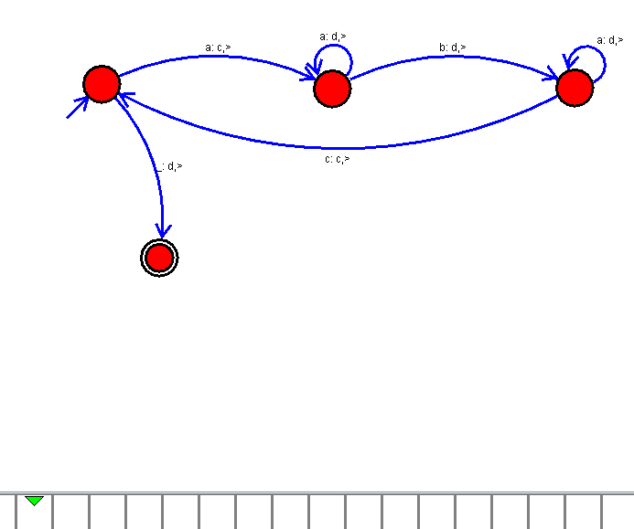

Output:

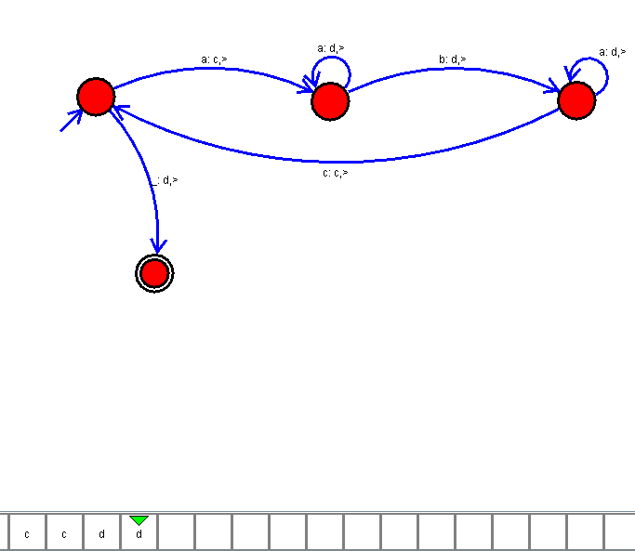

Result:

Thus the Tm as been implemented and executed successfully.